Deterrent sentences for the perpetrators of domestic violence:
Case notes on S v Muchekayawa 2012 (1) ZLR 272 (H) and S v Gudyanga 2015 (1) ZLR 238 (H)
By G. Feltoe
Introduction
Ideally marriage should be a relationship of love and affection and mutual respect of the marital partners but regrettably some husbands violently dominant their wives and create a living hell for their spouses. Cases of assaults by husbands upon their wives have increased despite attempts to curb this practice. Often assaults by husbands upon their wives become increasingly brutal over time and they may even end up causing the deaths of their spouses.
Wives may be reluctant to make criminal complaints against their violent husbands or may withdraw criminal complaints after lodging them. They may stay in violent and destructive relationships for a variety of reasons, including actual or perceived economic dependence on husbands for support of the family and cultural pressures upon wives to stay in the relationships. After assaults, violent husbands may often be apologetic and for a while will treat their spouses with kindness, leading the women to think that they may still mend their ways. Sometimes battered women may even blame themselves for the assaults and may suffer depression or loss of psychological energy necessary to leave their spouses.

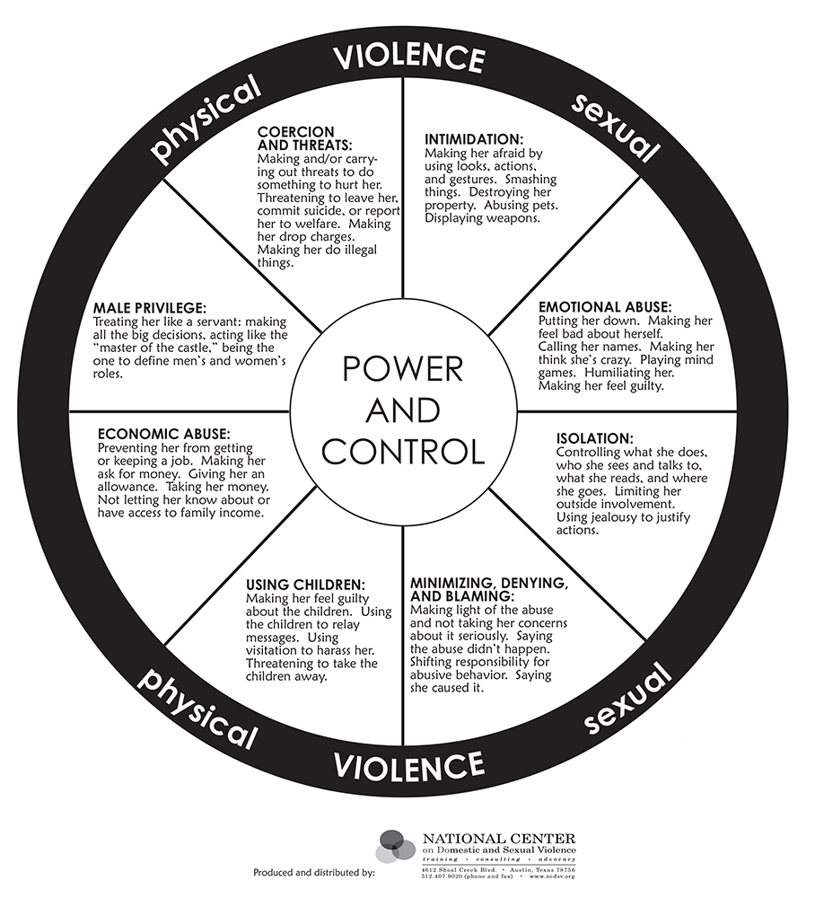

The courts have adopted the approach that one objective of the Domestic Violence Act [Chapter 5:16] to try to avoid breaking up families by using, wherever appropriate, alternate measures such as counselling and protection orders. However the primary objective of the Act is to offer protection to women who are in danger from their violent spouses, given that such harmful violent behaviour may escalate and might ultimately pose a threat to life. The Act is therefore more directed towards early preventive interventions which may curb violence. Thus the preamble to the Act reads: “To make provision for the protection and relief of victims of domestic violence and to provide for matters connected with or incidental to the foregoing.”
Where criminal charges are brought against violent husbands it is important that the courts impose adequately deterrent sentences. In some cases this will mean the imposition of custodial sentences even though the effect will be to break up families.

Criminal charges and sentences imposable
Section 4 of the Domestic Violence Act creates the criminal offence of domestic violence. This offence is punishable by a maximum sentence of a fine not exceeding level fourteen (currently $5000) or imprisonment for up to ten years or both such fine and imprisonment. Section 3 provides that the offence of domestic violence includes any unlawful act, omission or behaviour by an accused which results in death or the direct infliction of physical or sexual injury to a complainant.

Where a husband or intimate partner causes the death of his wife or partner by an assault, rather than charging domestic violence where the maximum sentence is imprisonment for ten year, the husband or partner must be charged under the Criminal Law (Codification and Reform) Act [Chapter 9:23] with either murder where the maximum sentence is the death penalty or culpable homicide where the maximum penalty is life imprisonment. The accused should be charged with attempted murder if he assault her with the intention to kill her for as for this offence he can be sentenced to death or up to life imprisonment.

Where the husband or partner assaults his wife or partner or even a previous intimate partner, he can either be charged with the offence of domestic violence or with assault under section 89 of the Criminal Law (Codification and Reform) Act as the maximum sentence for both of these crimes is imprisonment for ten years, although categorizing the assault under the generic offence of domestic violence may disguise the nature of the offence, that is a serious matter involving the intentional infliction of harm. It would appear that in cases of domestic violence, prosecutors prefer to prosecute under the Domestic Violence Act rather than the offence under the Criminal Code.

Where a husband rapes his wife, often after using violence to overcome her resistance, he should be charged with rape under the section 65 of the Criminal Law (Codification and Reform) Act. In terms of section it is no defence to rape, aggravated indecent assault or indecent assault that the complainant was the spouse of the accused.

Punishment for men guilty of domestic violence
In the case S v Muchekayawa 2015 (1) ZLR 272 (H) the accused, aged 29, went with his wife and his wife’s sister went to a beer drink. When they were going home, the complainant refused to board a taxi chosen by the accused and instead the three were taken home in a taxi selected by the complainant. As soon as the complainant and the accused arrived home, the accused questioned the complainant about why she had refused to use the taxi he had ordered. He then started to assault his wife. He used a log to hit his wife several times all over her body until she fell to the ground. He also picked up a stone and struck the complainant once on the top of her eye. The trial magistrate found that the complainant had sustained a deep cut as a result of the assault with the stone “showing that the force used was excessive.” Confusingly, however, the magistrate also found that the complainant did not sustain any serious injuries as was “shown by the fact that she did not seek medical attention.” The accused pleaded guilty to the charge of contravening section 4(1) read with section 3 of the Domestic Violence Act. The magistrate sentenced him to pay a fine of US$150 or in default of payment to imprisonment for thirty days. In addition he imposed a three months sentence of imprisonment wholly suspended for three years on condition the accused did not within that period commit any offence involving domestic violence and for which he is sentenced to imprisonment without the option of a fine.

On review the judge found that the sentence imposed was disturbingly lenient. He castigated the magistrate for his “startling conclusion that the injuries are not serious because the complainant did not seek medical attention.” He pointed out that section 5(2) of the Domestic Violence Act requires a police officer to whom a complaint of domestic violence is made or who is investigating a complaint to inform the complainant on how to obtain medical treatment and then return to the police with the medical report. The Judge said that magistrates dealing with such cases should always request the complainants to obtain medical reports in order for the court to assess not only the extent of the injuries sustained but also whether there is any likelihood of any permanent disability. The importance of medical reports in such cases could not be overemphasized. The magistrate should have postponed the passing of sentence pending the production of a medical report. The court correctly observed:
“Unless sufficiently deterrent sentences are imposed by the courts as provided by the Domestic Violence Act …the whole purpose of this piece of legislation will never be realized. Men will continue to brutalise their wives …Whilst each case should be decided on its own merits, in serious cases custodial sentences are appropriate”
In the case of S v Gudyanga 2015 (1) ZLR 238 (H) the accused, aged 20 and who was unemployed, had assaulted his 18 year old wife because she had refused to have sexual relations with him. The complainant who sustained a swollen mouth from the attack did not seek medical attention. The accused had previously committed a similar offence for which a suspended sentence of two months’ imprisonment had been imposed. In the present case the trial magistrate sentenced the accused to two months’ imprisonment and brought into operation the previously suspended sentence of two months. The total sentence imposed was thus a custodial sentence of four months. Factors considered in mitigation were that the accused was unemployed, he had a minor child and he had pleaded guilty and had shown contrition and he acted out of frustration because he had been denied his so-called “conjugal rights.” In aggravation the court took into account that he was a repeat offender.

The regional magistrate sent this case for review to the High Court as the regional magistrate considered that the sentence was too harsh because it was likely to break up the family which is contrary to what the regional magistrate considered is one purpose of the Domestic Violence Act. The regional court magistrate stated that the trial magistrate should have considered imposing a sentence of community service instead of the custodial sentence.

The High Court upheld the sentence of the trial magistrate finding that he had properly exercised his discretion and there had been no misdirection on his part. The High Court stressed that there is no hard and fast rule that, because the purpose of the Domestic Violence Act is to try to keep families together, custodial sentences must not be imposed. Custodial sentence may be necessary in serious cases and where there has been repeat offending. The High Court then gave a list of the sort of factors that the trial court should consider in deciding upon the appropriate sentence when a husband assaults his wife. The factors listed include the following:
- the extent of the complainant’s injuries as evidenced by medical affidavit;
- the possibility of permanent injuries;
- whether any of the complainant’s property was damaged;
- whether the accused has previous convictions for assault upon his wife;
- whether the marital relationship between the parties is now so hostile and acrimonious that reconciliation seems unlikely;
- whether the accused pleaded guilty and showed contrition;
- whether the accused made reparations or amends;
- the accused’s reason for assaulting his wife e.g. was he provoked, did he find out or suspect that she was committing adultery etc.;
- whether the parties are willing to undergo counselling.

Conclusion
Wives need to be protected against dangerously violent husbands and other intimate partners. Police officers must properly investigate all cases involving domestic violence and must inform the victims of their rights, including their right to lodge criminal complaints against their husbands. They should also advise the victims to be medically examined. Where prosecutions are brought but the victims have not yet been medically examined, the matter should be postponed to allow a medical affidavit to be drawn up and produced in evidence.
Taking into account all the relevant considerations bearing on sentence, in serious cases, such as where wives have been badly injured, custodial sentences may be the only appropriate sentence even if the accused is a first offender. Custodial sentences may also be required where the accused has previous convictions for this offence or has repeatedly violated protection orders.
Much support should be given to assist parties to manage their relationships without using violence, there are some marriages and relationships that are so broken as a result of violence that they can no longer be mended and simply pose a grave threat to the physical wellbeing of females in such relationships.

I am extremely grateful to Professor Julie Stewart for all her helpful comments and observations when I was writing this paper. Any errors in this paper are, of course, my own.
Section 47(2)
Section 49
Section 47(3)
Section 68
At 274D
The nature of the weapon used and the intent of the assailant could be added here.

