THE STATE
versus
MOSES CHIPUVE

HIGH COURT OF ZIMBABWE BACHI MZAWAZI J CHINHOYI, 25 October, 2023

Criminal Review

BACHI MZAWAZI J: This is an automatic review record brought in terms of s54 (2) of the Magistrate Court Act [Chapter, 7:10] after the trial court convicting the accused person of robbery as defined in s126(1) of the Criminal Law Codification and Reform Act[Chapter,9:23] in May 2022, was of the opinion that the appropriate sentence of eight to ten years in the circumstances of that case called for a sentence which exceeded his five-year ceiling jurisdiction.
Upon receipt of the record, this court proceeded in terms of s227 of the Criminal Procedure and Evidence Act, [Chapter 9:07], which in ss227(2) enjoins a judge faced with such proceedings to utilize the powers bestowed upon him or her by subsections (1) and (2) of the High Court Act [Chapter 7:06]. So instead of being constricted to the request of merely imposing an increased custodial term at the dictates of s54 (2) of the Magistrates Court Act, and as stipulated in s228 of Chapter 9:07 above, the High Court’s criminal reviews powers are invoked so as to enable the judge to review the whole proceedings of the trial court to see whether they are in accordance with real and substantial justice before deciding to sentence the accused or not. See, Reid Rowland, A Guide to Criminal Procedure in Zimbabwe Chapter 25, Legal Resources Foundation, 1997 edition, Mandizha v S HH 275 –A-90, Prof Geff Feltoe Magistrate’s Handbook.
In ascertaining whether the proceedings are in accordance with real and substantial justice the guiding factors are the analysis of the conviction and sentence against the backdrop of the facts, evidence and the law to see whether they meet the tenets of justice and fairness. See Dangarembizi and Anor 1987 (2) ZLR at 196 and Magistrate’s Handbook page 462. It is only after the judge is happy with the trial court’s findings that he or she then proceeds to invite the accused person for sentence

The nobility of this safeguard mechanism is that once a High Court judge restricts himself to the sentence only the door for the record to be brought on review on the substantive procedures will be closed which will result in an injustice to the accused as an appeal on that record after the sentence of the High Court lies with the Supreme Court.
That being so, an over view of the facts is that, the accused in the company of two other assailants now on the run broke into the complainant’s house late at night assaulted him and stole several items including some refined gold and cash in United States dollars. The accused person is said to have been arrested at the implication of one of the co-accused. He was tried and convicted after a full trial. As had already been highlighted above the trial court then felt a stiffer penalty was appropriate but beyond its sentencing jurisdiction limits, hence this referral.
Accused raised two key defences, that of firstly, an alibi, that at the time of the commission of the offence he was at Empress Mine. It is common cause that this defence was raised at the appropriate stage, upon arrest and necessitated police investigations. Indeed, the investigating officer testified in one sentence that he visited the place and the people denied. The trial court found that explanation enough and dispelled the accused’s defence on alibi just like that.
What is not clear on record is the address where the police detail went to verify the alibi, the details of the person or persons he spoke to and their exact words. It was crucial for the police officer to give this additional information, if indeed they did investigate the alibi. Moreso, when police investigate they are supposed to do so in pairs or in numbers. Thus the veracity of their statements could only be tested on sufficient information, bearing in mind that an accused person has no onus to prove his alibi. See, S v Madziwa S-191-90. In the absence of such information was the court certain that the alibi was accurately, investigated on the correct persons and addresses.
The defence of an alibi is simply an explanation by an accused person that he was not at the crime scene on that particular day and time. The law places the onus on the accused to mention his defence strategy of an alibi at the onset of arrest not as an afterthought, so as to eliminate tailored evidence and allow the police to investigate. After that the accused has no

burden of proof to prove his alibi. This was amply stated in Hoffman and Zeffertt, South African Law of Evidence 4ed at p619, where such onus is placed on the State. See R v Biya 1952(4) SA514(A), S v Khumalo, & Ors 1991 (4) Sa 310(A) at 327.
In Chibowa v The State HH 772/19, it was emphasized that an alibi must be proved by the State beyond a reasonable doubt. In the case of S v Maleto 1981, SACR at 127, it was held that an accused person bears no burden to prove his alibi, if there is a reasonable possibility that the State has failed to discharge the onus vested on it to rebut the alibi defence, then the accused should be acquitted. See, Sv Musike 2013 (1) SACR 517 where it was also noted that, once an alibi has been raised it has to be acceptable unless it can be proved that it is false beyond a reasonable doubt
In light of the above observations and the extrapolation of the law on alibi the accused’s defence of alibi was not rebutted. The State accordingly failed to discharge its onus on the alibi. Accordingly the court erred in placing reliance on the scanty mere say so of the investigating officer.
In assessing the accused’s second line of defence that of mistaken identity, reliance is placed in the case of Mutters and Anor v The State –S-66-89 where the fallibility of human recollection under pressure or an hostile environment is questionable. As such identification evidence has to be treated with great caution. Several factors have to be considered cumulatively for the identification to pass the test. Some of these, are visibility, lighting, description of special or peculiar features and gestures amongst others. See, Makoni & Ors v the State -S -67/89, S v Nkomo& Anor 1989(3) ZLR 11, Madziwa v the State-S-191/90..
On interrogation of the evidence of identification relied by the court of first instance, the identification evidence was of a husband and wife team. There are cautionary rules of evidence surrounding such evidence. A couple hardly gives variant information. Usually, it cannot be ruled out that the evidence is rehearsed so as to be corroborative. In the current case, there are inconsistencies as to the knowledge and association of the complainant and the accused prior to the offence. There is a version which is part of the record that the accused was a business or work associate of the complainant. This was never pursued or buttressed by evidence. Actually

the complainant who was the first witness said he only knew the accused as one of the local boys.
Further, in pursuance of the 1st witnesses’ evidence, he said the two people, he recognized before being felled by a blow to the head where the two fugitives from justice. This was from his evidence in- chief. Later on, on cross examination he claimed it was the accused who struck him with that heavy blow.
Putting all his evidence into perspective, he exclaimed that the arrival of his attackers was heralded by the barking of a dog. Meaning, the atmosphere was already charged with the abrupt intrusion from the intruders and the common fear associated with such interactions. It is the exasperating if not mind boggling that after the first witness, the complainant managed to convincingly identify the accused as one of the perpetrators yet he testified that he only saw two of the people now on the run enter and not the accused. If the impact of the blow felled him to the ground it is difficult to comprehend or envisage one being able to clearly visualize much. Moreso, taking into account the whole traumatizing environment. Further, the impact of such a blow hardly leaves one with no dizziness. We do not believe that under these circumstances the dangers of mistaken identity were eliminated given the general atmosphere obtaining at the time. See, Mutters and Anor, above
In addition, the statements that were tendered to the police when events were still fresh and not prone to exaggeration where to the effect that as soon as the intruders got into the house they ordered the second witness, the wife to cover herself with a blanket. The second witness then testified that given the volatility of that situation and the attack on her husband she did identify the accused after being ordered to cover herself and was under a blanket, which in my view is improbable.
It cannot be eliminated that the story of prior knowledge of the accused was trumped up only to panel beat the investigating officers’ story on their omission to conduct an identification parade. It is of utmost importance that the police should think out of the box and carry out supporting and or corroborative independent investigations, sources and evidence other than placing too much reliance solely on the mere say so of victims of crime or the word of mouth of

people. The witness statements should be the starting point. From then it is the duty of the investigating officer to search for other evidence, to buttress or test the veracity of the information received. In the present case, even if they had information of prior knowledge of the attackers, which we have already discredited herein, it was imperative that they conduct an identification parade to test that theory of prior knowledge instead of bringing half -baked evidence creating loopholes for the defence.
Conclusively, it is apparent that, in the face of an alibi defence and the shortfalls observed above on identification, the State did not prove its case beyond a reasonable doubt. No matter how serious the offence is the law thrusts the onus of proof beyond a reasonable doubt not on the accused to prove his innocence but on the State. See S v R v Difford 1937 AD.
The accused’s defence that after learning of the offence he informed the police leading to the arrest of his own brother is more probable if weighed against the investigating officer’s evidence which in our view was not credible. It did not pass the test of credibility in that, no thorough investigation was done on the alibi, the shortfalls in the identification parade, unsatisfactory investigation and production in court of the phone which was said to have been found with the accused thereby linking him to the offence. It turned out that the phone was not procedurally produced and the complainant never identified it as his own. This leaves the accused’s defense that after learning of the offence he informed the police leading to the arrest of his own brother more probable.
Lastly, it has always been a guiding principle that given the manner some of the investigations are done, it is better to err on the side of caution and release a single guilty person than to send an innocent man to jail.
Accordingly, the conviction of the court aquo in light of the analysis of the evidence and the law against the facts is unsafe and not in accordance with real and substantial justice. It is set aside.The accused person is accordingly found not guilty and acquitted.
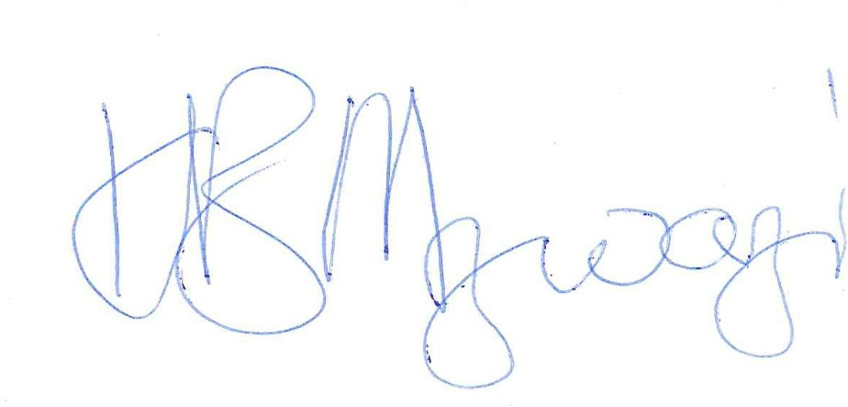
Honorable Mrs. Justice Bachi-Mzawazi Honorable Mrs. Justice Muzofa , I agree
National Prosecuting Authority

