CHATPRIL ENTERPRISES (PVT) LTD
Versus
MSI POONJA PROPERTIES (PVT) LTD

HIGH COURT OF ZIMBABWE
COMMERCIAL DIVISION HARARE 5 & 26 October 2023
MANZUNZU and CHILIMBE JJ

Civil appeal
E. Mubaiwa with K. Siyeba, for appellant
R.G. Zhuwarara with D. Chemhere for respondent

CHILIMBE J
BACKGROUND
[ 1] This is a landlord (respondent) and tenant (appellant) dispute. The parties entered into a verbal lease agreement in 2008 over premises cited as 38 Cameron Street, Harare. Respondent instituted proceedings in the magistrate`s court seeking the appellant`s ejectment plus ancillary relief. The respondent alleged breach of the lease agreement in that (i) appellant failed to keep premises in good repair, (ii) defaulted on payment of municipal charges (iii) illegally sublet the premises and (iv) effected unauthorised alterations to the premises. The respondent contested the suit.
[ 2] The court a quo found for the respondent. It issued, on 30 September 2022, an order confirming the cancellation of a verbal lease agreement between appellant and respondent. The court also ordered the ejectment of appellant from 38 Cameroon Street.
THE GROUNDS OF APPEAL
[ 3] The appellant filed a notice of appeal against the judgment of the court a quo raising the following grounds; -
- The court a quo misdirected itself in determining that the documents that Appellant sought to adduce as further evidence was (sic) not material and would not assist the court in determining the case before it.
- The court a quo misdirected itself in refusing to accept reports from the City of Harare authorised by Chirombo the Architect.
- The court a quo misdirected itself in finding that the roof of the shop needed to be repaired.
- The court a quo misdirected itself in finding that the ceiling and toilets were in need of repairs.
- The court a quo misdirected itself in failing to consider the photographs of the building tendered by the Appellant.
- The court a quo misdirected itself in finding that it was the responsibility of Appellant to repair telephone cables that were hanging on the veranda.
- The court a quo misdirected itself in finding that the shop was being sub-let to other tenants.
- The court a quo misdirected itself in finding that Appellant had failed to pay rentals.
THE PRELIMINARY OBJECTION
[ 6] A preliminary point objecting to the validity of the grounds of appeal was taken by Mr. Zhuwarara on behalf of the respondent. Counsel contended that the grounds of appeal fell foul of Order 31 Rule 4 (4) of the Magistrate Court Rules,2019. All 8 of them lacked precision and concision.
[ 7] Appellant`s 8 grounds of appeal trained their complaint against the court a quo`s factual findings. But they did not venture forth to particularise the exact basis upon which the court`s factual findings were being faulted.
[ 8] Mr. Zhuwarara relied on, and laid considerable emphasis on the decisions of S v McNab 1986 (2) ZLR 280 (S); S v Jack 1990 (2) ZLR 166 (S); Chikura & Anor v Al Sham`s Global BVI SC 17-17, and Kunonga v The Church of The Province of Central Africa SC 25-17. The collective guidance issuing from those decisions was consistent. Grounds of appeal had to comply with the rules in order to be validly before the court. The essence of such compliance lay in grounds being concise and precise.
[ 9] Mr. Mubaiwa` s response went thus; -firstly, it was incorrect to label all the 8 grounds of appeal as predicated entirely on the court a quo`s factual findings. Grounds 1,2, 5 and 6 distilled to the essence of their complaint, findings on matters of law. Secondly, counsel urged the court to discount the inelegant drafting behind the grounds of appeal in question. There was still, that regrettable drafting aside, sufficient flesh next to the proverbial bone to clothe the grounds with validity.
[ 10] Grounds 3,4,7 and 8 dealt with findings of fact. They each criticised the basis upon which the trail court reached its conclusions. Thirdly, Mr. Mubaiwa submitted that even if the court condemned all but one ground of appeal, that single ground was enough to carry the notice and grounds through. He drew attention to the first grounds in particular, as having clearly addressed the matters of law raised by appellant.
THE LAW
[ 11] As a starting point, the authorities state that in order for it to be valid, a notice of appeal must comply with the rules. It must do so in every respect. Otherwise it will be rejected as void and of no effect by the court. The Supreme Court expressed this position as follows in Christopher Sambaza v Al Shams Global BVI Limited SC 3-/18 per UCHENA JA [ pages 4-5]
“It is clear that r 29 (1) (a) to (f) provides the mandatory attributes of a compliant Notice of Appeal. A diligent legal practitioner is expected to use it as a check list in formulating a compliant Notice of Appeal. It clearly and succinctly lays out what must be stated in a notice of appeal.
The use of the words “which shall state” signifies the mandatory nature of r 29 (1). It means if what the rule says must be stated is not stated the notice of appeal will be fatally defective.
In Freezewell Refrigeration Services (Private) Limited v Bard Real Estate (Private) Limited SC 61-03, this Court in explaining the effect of the mandatory provisions of r 29 (1), quoted the case of Talbert v Yeoman Products (Private) Limited SC111-99 where MUCHECHETERE JA held that a notice of appeal which does not comply with the provisions of r 29(1) was null and void.”
[ 12] The burden to comply with the rules must be understood from the following context. Rule 29 (1) of the Supreme Court Rules referred to in Sambaza v Al Sham`s (supra) requires appellants to adhere, in drawing up the grounds of appeal, to rule 32. Rule 32 in turn prescribes that grounds of appeal “shall be set forth concisely”.
[ 13] For appeals to this court, the appellant is directed by Order 31 rule (4) (c) of the Magistrate`s Court Rules [ which version] which provides that “A notice of appeal or of cross appeal shall state…in the grounds of appeal, concisely and clearly the findings of fact or rulings of law appealed against”.
[ 14] Order 31 (4) (c) can be split into two parts. Firstly it requires grounds of appeal to be concise and precise. Secondly, and additionally, the same grounds of appeal must, clarify the findings of fact or law appealed against. As regards the first, precision and concision are self-explanatory terms. Grounds of appeal that are prolix have been condemned as failing the test of concision and precision. In Kunonga v The Church of The Province of Central Africa (supra) the court commented as follows at [29]; -
[29] In John Chikura N.O. & Anor v Al Shams Global BVI Limited, SC 17/2017, the notice of appeal filed with this court spanned eleven pages. Of those pages, six comprised eighteen grounds of appeal. The judgment appealed against consisted of eleven pages. In holding that the grounds of appeal were unnecessarily long, incoherent and prolix, this court, after quoting the remarks of Leach J in Songono v Minister of Law and Order (supra), struck the matter of the roll, remarking at pages 3-4 of the cyclostyled judgment:
“It is not for the court to sift through numerous grounds of appeal in search of a possible valid ground; or to page through several pages of “grounds of appeal” in order to determine the real issues for determination by the court. The real issues for determination should be immediately ascertainable on perusal of the grounds of appeal …. The grounds of appeal are multiple, attack every line of reasoning of the learned judge and do not clearly and concisely define the issues which are to be determined by this court …”
[ 15] In the same decision of Kunonga v The Church of The Province of Central Africa, GARWE JA (as he then was) made a survey of the various authorities generally on the subject. The learned judge of appeal cited with approval KORSHA JA`s remarks on of what concision and precision in The Master of the High Court v Lilian Grace Turner SC 77/93 that “… by concise is meant brief, but comprehensive in expression …”
[ 16] As regards the second aspect of the two parts noted in [ 13] above, the court stressed the importance of distinguishing in the grounds of appeal, findings of fact and law. The court held cited the below decision at [ 26] in Kunonga; -
“[26] In Van de Walt v Abreu 1994(4) SA 85 (W) Stegmann J made an exhaustive review of case law relating to notices of appeal from the Magistrates Court in South Africa. That case is authority for the proposition, based on the Magistrates Court Rules of South Africa, that there are two distinct requirements, both of which have to be satisfied, for a proper notice of appeal disclosing a valid ground of appeal. Firstly, the notice must specify details of what is appealed against (i.e. the particular findings of fact and rulings of law that are to be criticized on appeal as being wrong) and secondly, the grounds of appeal (i.e. it must indicate why each finding of fact or ruling of law that is to be criticised as wrong is said to be wrong. For example, because the finding of fact appealed against is inconsistent with some documentary evidence that shows to the contrary; or because it is inconsistent with the oral evidence of one or more witnesses; or because it is against the probabilities.”
[ 17] It has been held that in the quest to frame grounds of appeal that meet the requirements of concision and precision, an appellant will not be strictured to the rigidity of set terminology or nomenclature. Mr. Mubaiwa referred the court to the qualification of the above remarks by GARWE JA (again as he then was) in Zvokusekwa v Bikita Rural District Council SC 44-15. The court also explained how to distinguish grounds of appeal targeting findings of fact and those predicated on findings of law.
[22] One must, I think, be guided by the substance of the grounds of appeal and not the form. Legal practitioners often exhibit different styles in formulating such grounds. What is important at the end of the day is that the grounds must disclose the basis upon which the decision of the lower court is impugned in a clear and concise manner. If it is clear that an appellant is criticising a finding by an inferior court on the basis that such finding was contrary to the evidence led or was not supported by such evidence, such a ground cannot be said to be improper merely because the words “there has been a misdirection on the facts which is so unreasonable that no sensible person …… would have arrived at such a decision” have not been added thereto. If it is evident that the gravamen is that an inferior court mistook the facts and consequently reached a wrong conclusion, such an attack would clearly raise an issue of law and the failure to include the words referred to above would not render such an appeal defective. After all, there is no magic in the above stated phrase and very often the words are simply regurgitated without any issue of law being raised. See, for example, the case of Sable Chemical Industries v David Peter Easterbrook SC 18/10 where it was noted that the words “erred on a question of law” are sometimes included in grounds of appeal but without any question of law actually being raised.
ANALYSIS OF THE GROUNDS OF APPEAL
[18] We will now proceed to apply the above legal principles to the facts in analysing the grounds of appeal. In doing so we pose two questions (a) are the grounds of appeal attacking findings of fact or law and (b) in either case do they articulate, with sufficient clarity and conciseness, the appellant`s complaint toward the court a quo`s decision?
[ 19] Ground 1 The court a quo misdirected itself in determining that the documents that Appellant sought to adduce as further evidence was (sic) not material and would not assist the court in determining the case before it.
Applying the guidance in Zvokusekwa, this ground, in essence, attacks the court a quo`s finding on a matter of law. The court a quo is criticised for rejecting evidence material to the determination of the matter before it. The fault that blighted the court a quo`s decision in ruling out such evidence is presumably the inability of the court to distinguish evidence that is relevant from that which is not. But the court a quo made a discretionary decision on that point. The grounds of appeal does not venture further to found the basis for criticising the discretionary conclusion of the trial court.
[ 21] Grounds 2 and 5
- The court a quo misdirected itself in refusing to accept reports from the City of Harare authorised by Chirombo the Architect.
- The court a quo misdirected itself in failing to consider the photographs of the building tendered by the Appellant.
These two grounds also attack the court a quo`s finding on matters of law. Like the first ground of appeal, this second one quarrels with the trial court`s rejection of evidence deemed essential to the disposal of the dispute before it. But unlike in the first ground, there is no averment in the second one, that the reports concerned were material. The grounds is presumptuous. It is not, in our view precise in conveying the fault in the trial court`s decision.
[ 22] Grounds 3,4,6,7 and 8 address the court a quo`s findings of fact. These grounds deal respectively with the court`s findings on repairs and maintenance (roof, toilet, ceiling and telephone cables), subletting and default of rentals. Quite clearly, these grounds lay no basis for criticising the trial court`s conclusions. They do not advance the reason why what is said to have been wrongly done was wrongly done.
DISPOSITION
[ 23] The grounds of appeal are bereft of concision and precision. They offend the rules and are therefore invalid before the court. The appellant is therefore non-suited by the defects in its papers.
Accordingly is hereby ordered that; -
The appeal be and is hereby struck of for failure of the notice of appeal`s compliance with the rules.
MANZUNZU J -I agree [ Signed on original]

Bherebhende Law Chambers – appellant`s legal practitioners
Coghlan, Welsh and Guest-respondent`s legal practitioners

CHILIMBE ___ [ 12/10/23]
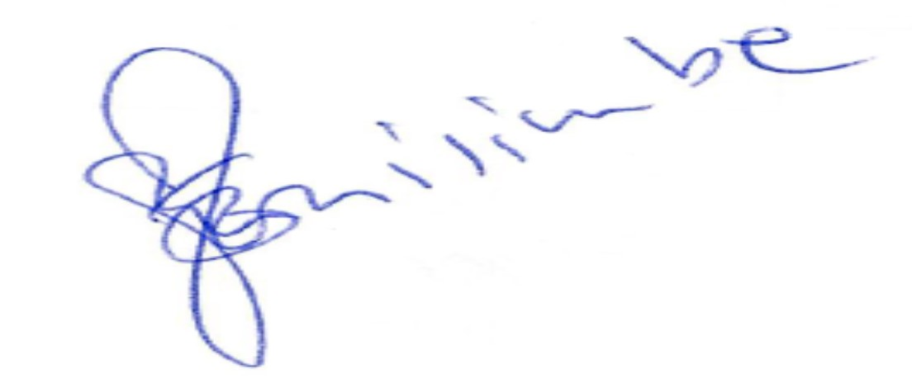

HH 561-23 HCHC 296/22

